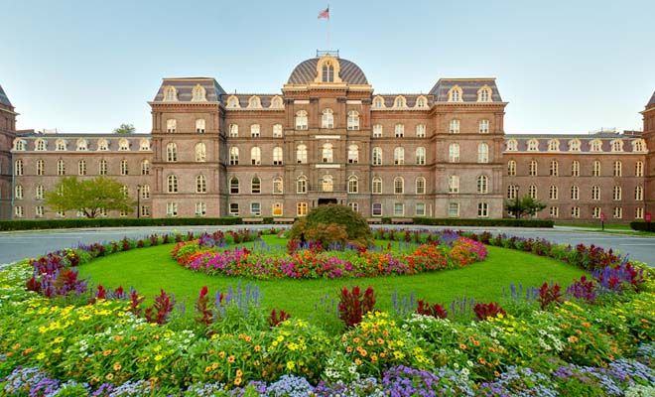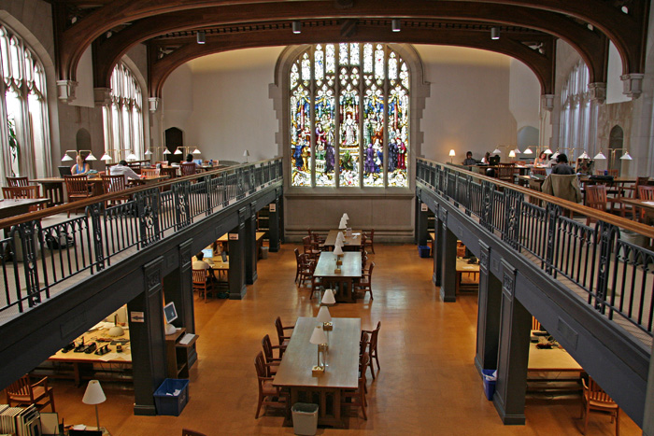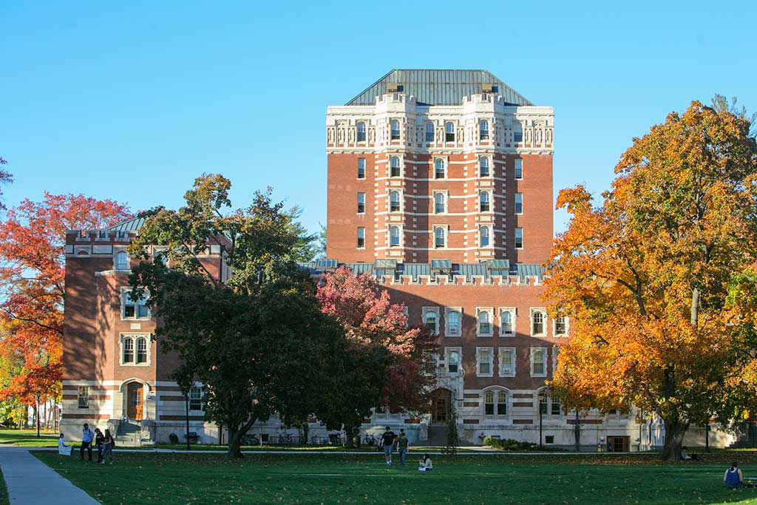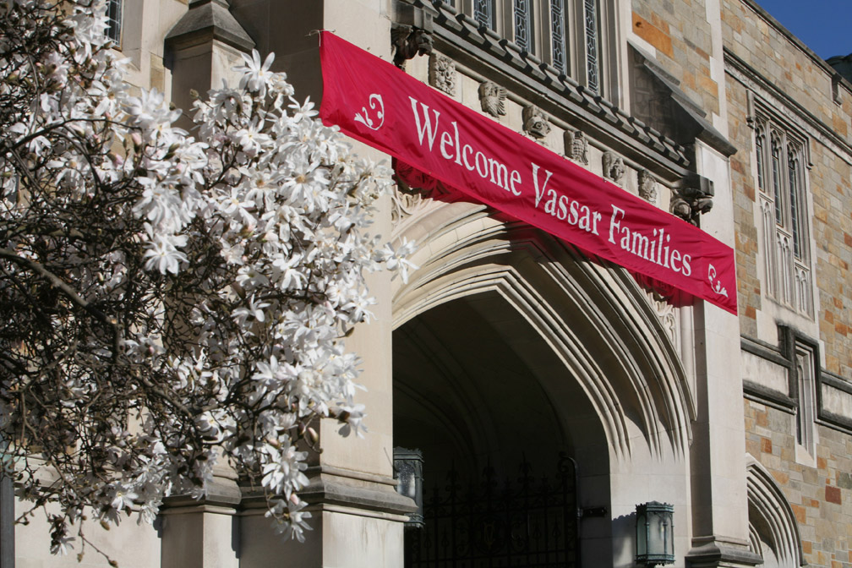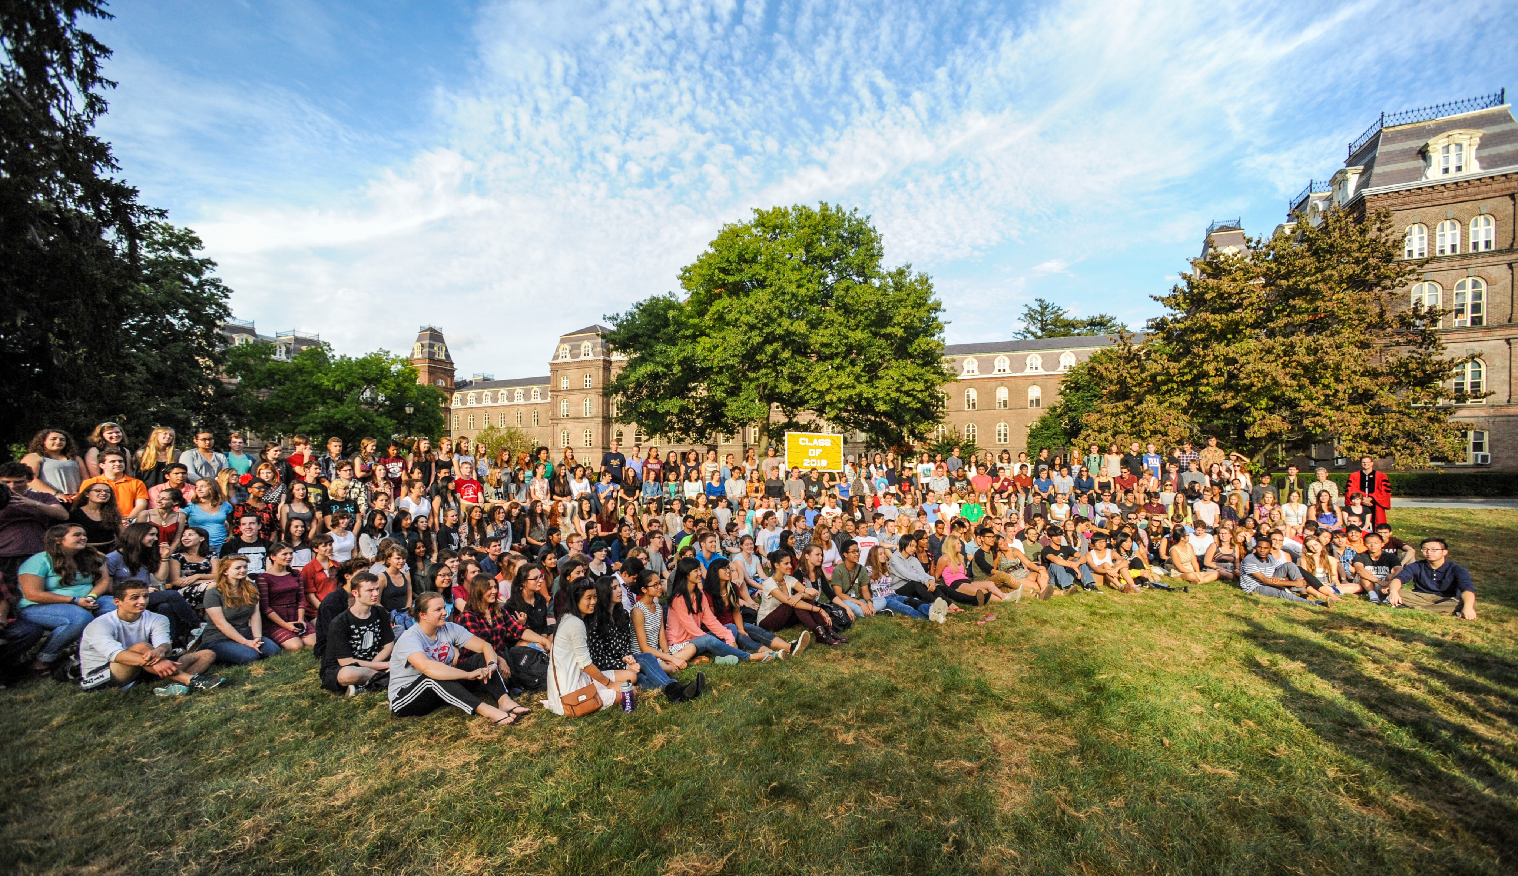

Resources

Admissions Viewbook. A look inside Vassar. [admissions.vassar.edu/viewbook/](http://admissions.vassar.edu/viewbook/)

Athletic schedule. Includes webcast schedule. Go Brewers! [vassarathletics.com/calendar](http://www.vassarathletics.com/calendar.aspx)

Campus Map. [campusmap.vassar.edu](https://campusmap.vassar.edu)

Career Development Office. [careers.vassar.edu/parentsandfamilies](http://careers.vassar.edu/info/parents-and-families/)

Course catalogue. Course descriptions, requirements, majors, procedures. [catalogue.vassar.edu](http://catalogue.vassar.edu)

Dean of the College. [deanofthecollege.vassar.edu/](http://deanofthecollege.vassar.edu/)

Dean of Students. [deanofstudents.vassar.edu/](http://deanofstudents.vassar.edu/)

Dean of Studies. [deanofstudies.vassar.edu/](http://deanofstudies.vassar.edu/)

Dining at Vassar. Meal plans and locations. [vassar.campusdish.com/](http://vassar.campusdish.com/)

Financial Aid and Tuition. [admissions.vassar.edu/financial-aid/](http://admissions.vassar.edu/financial-aid/)

Freshman Handbook. [freshmanhandbook.vassar.edu/](http://freshmanhandbook.vassar.edu/)

Freshman Orientation. New students schedule and resources [newstudents.vassar.edu/orientation/](http://newstudents.vassar.edu/orientation/)

Health Insurance Requirements. [studentaccounts.vassar.edu/insurance](http://studentaccounts.vassar.edu/insurance/student-health-insurance.html)

Learning, Teaching and Research Center. [ltrc.vassar.edu/](http://ltrc.vassar.edu/)

Office of Campus Life and Diversity. [campuslifeanddiversity.vassar.edu/](http://campuslifeanddiversity.vassar.edu/)

Office of Residential Life. Policies and procedures. [residentiallife.vassar.edu](http://residentiallife.vassar.edu/procedures/)

The Family Educational Rights and Privacy Act [FERPA]. [registrar.vassar.edu/ferpa/ferpa-policy](http://registrar.vassar.edu/ferpa/ferpa-policy.html)

The Miscellany News. Student newspaper. [miscellanynews.org](http://miscellanynews.org)

VCash. Prepaid debit account on the VCard. [card.vassar.edu/vcard/](http://card.vassar.edu/vcard/)

Welcome to Vassar

All parents and guardians of current Vassar students are valued members of our community. We encourage you to keep up-to-date on Vassar news and events, connect with fellow parents and alumnae/i and, of course, visit your son or daughter on campus.

**IMPORTANT DATES**

Freshman Drop off: August 22, 2016

Families Weekend: September 23-24, 2016

153rd Vassar College Commencement: May 28, 2017

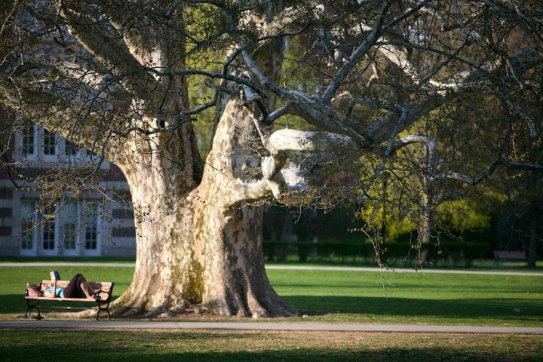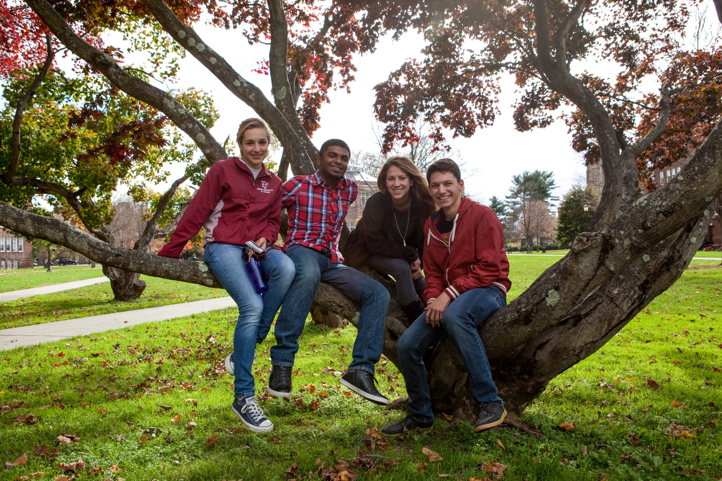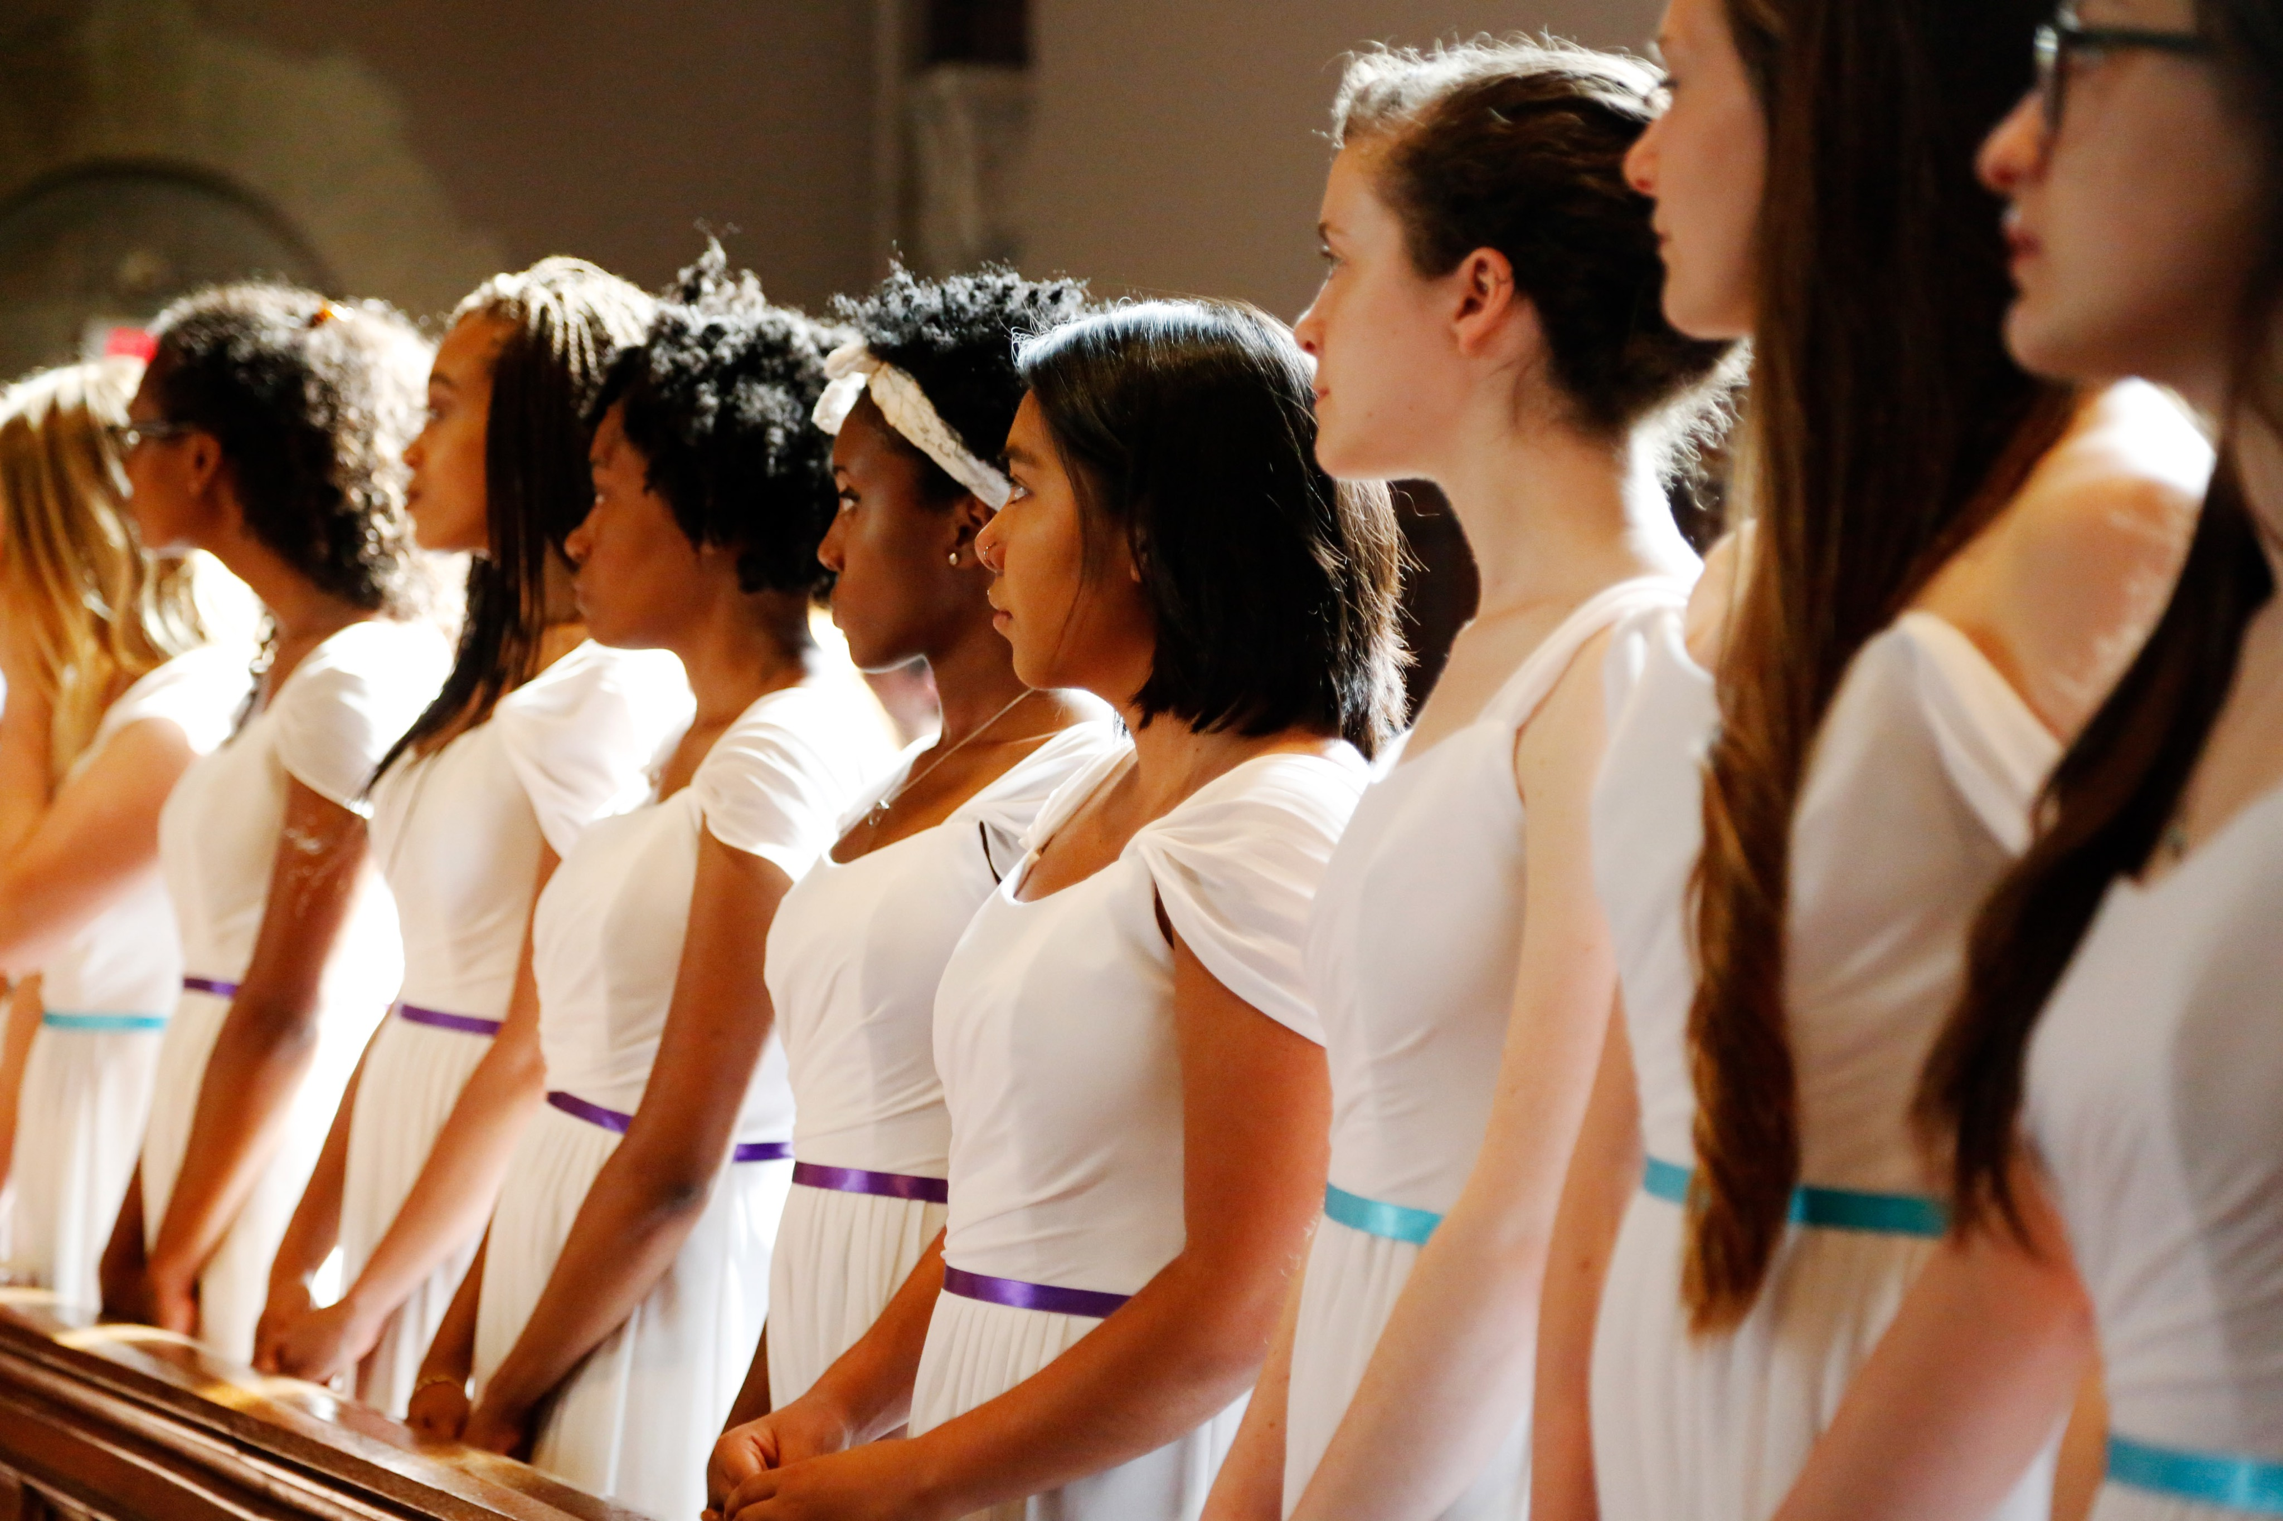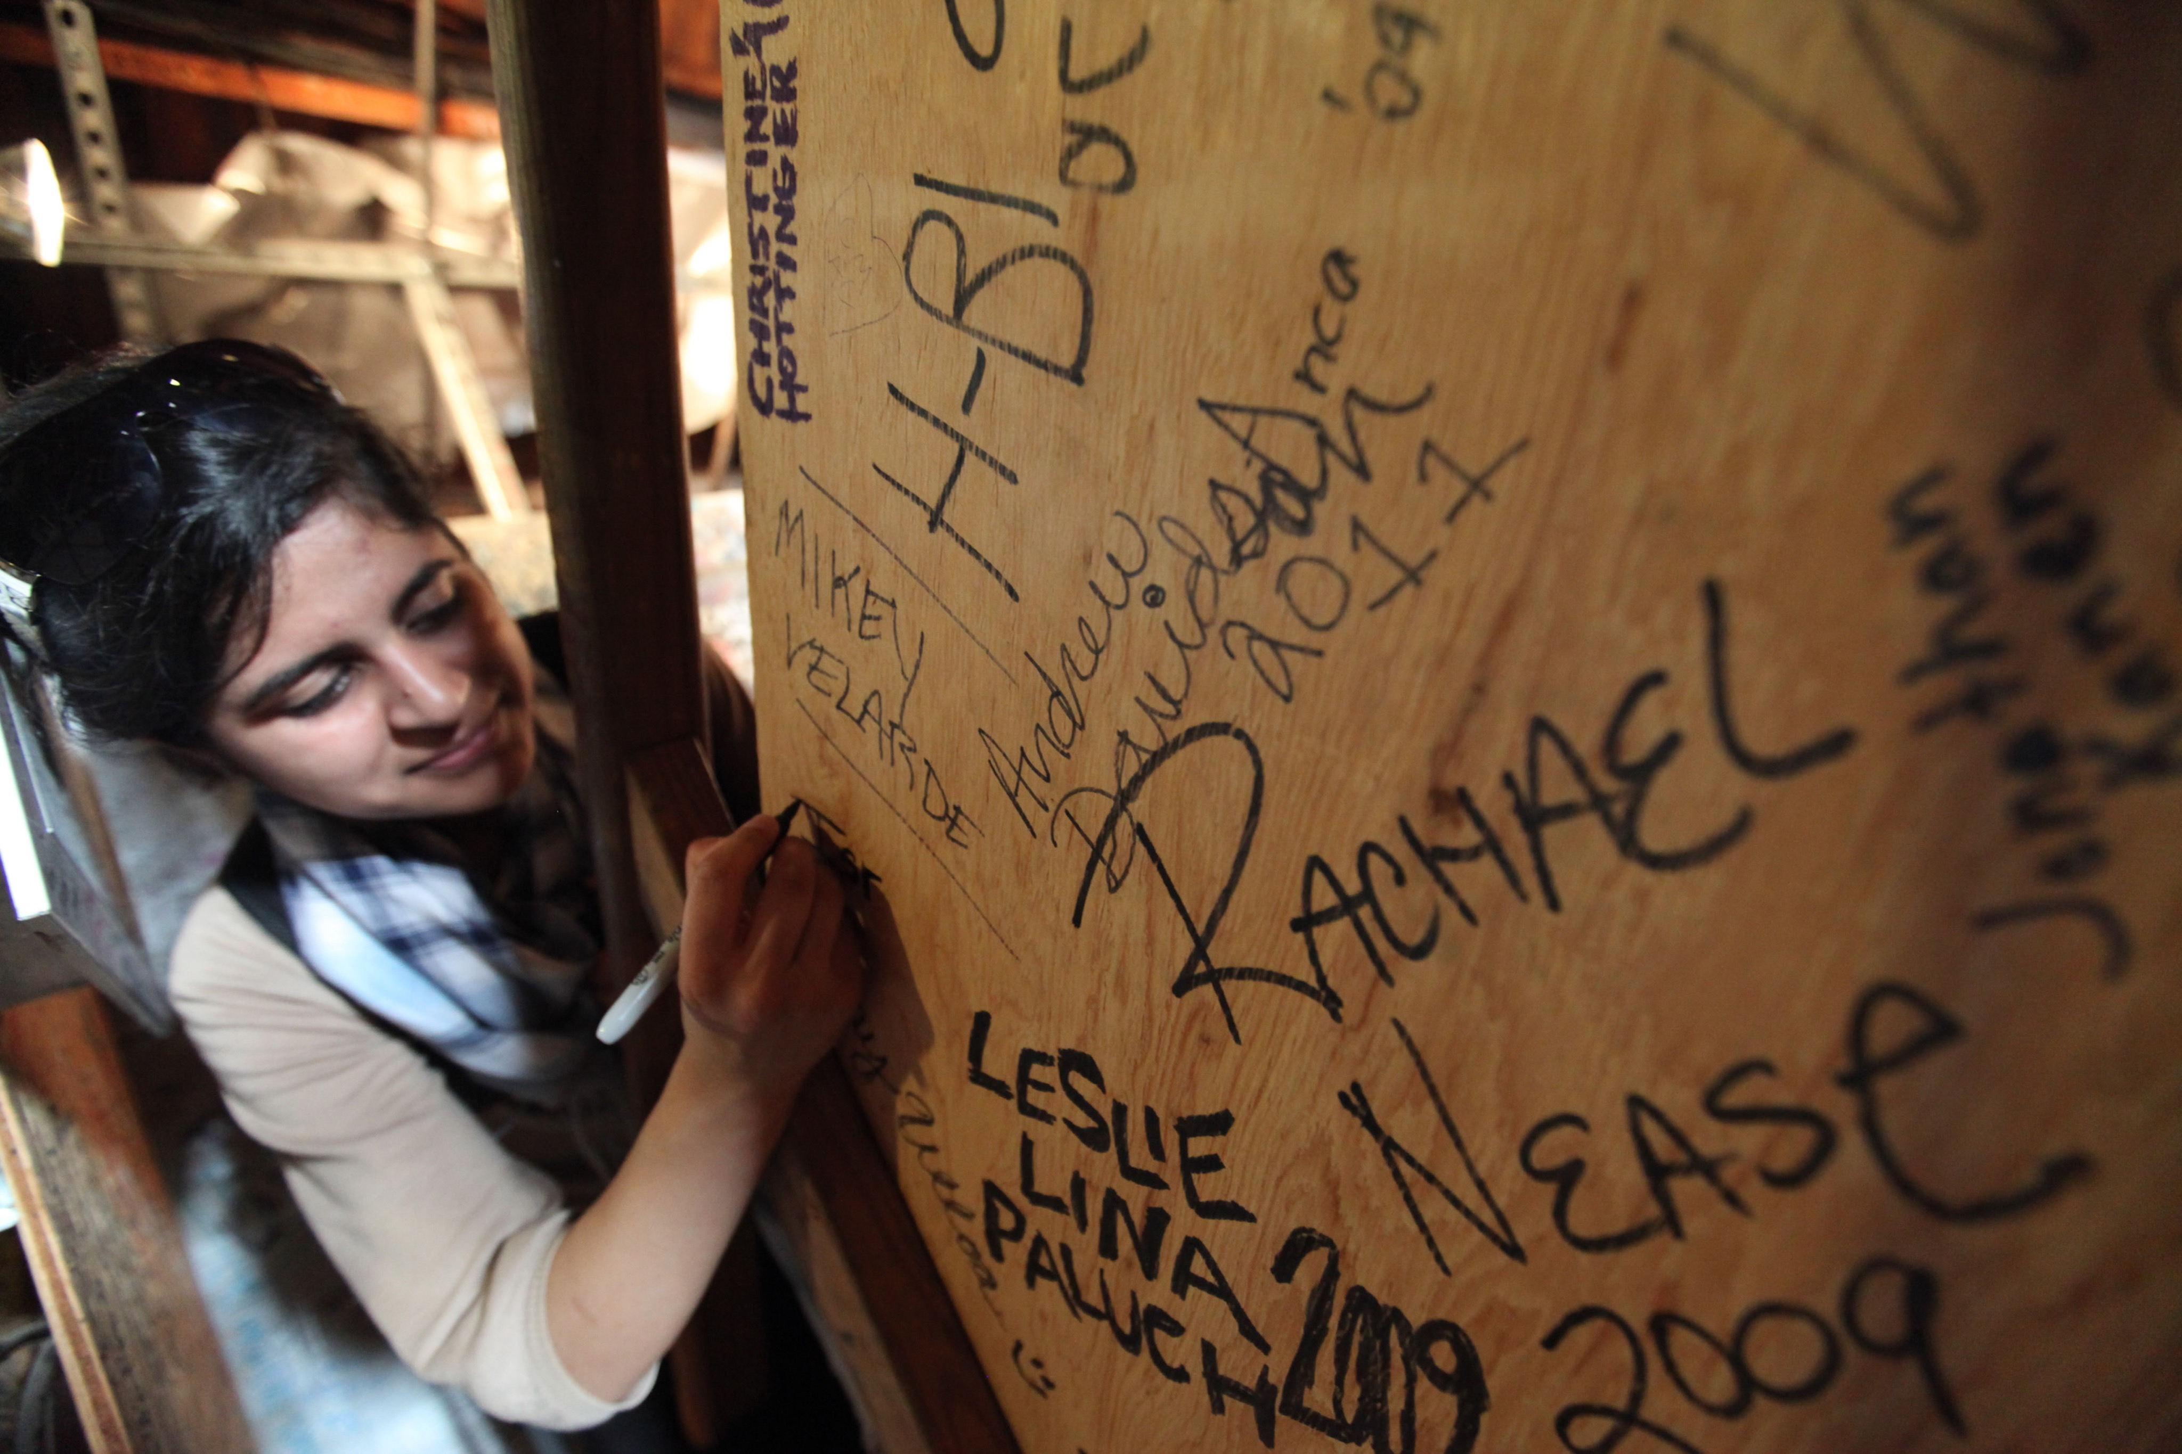

Dear Vassar Parents and Families,

As co-chairs of Parent Giving, we welcome parents to the Vassar community for the 2016-2017 academic year.

We’ve experienced first hand the intellectual and personal growth that transforms students who attend this extraordinary college. And we all, as parents, play an integral role in supporting these young people throughout their Vassar experience. here are a few ways that you can impact campus life for all Vassar students.

* + - Get involved with our [Career Development Office](http://careers.vassar.edu/info/parents-and-families/) (CDO). Please consider partnering with the CDO, an invaluable resource in helping Vassar students make the challenging transition from college to career. Whether mentoring a student, sharing your professional experience, offering an internship, or hiring a Vassar grad, you can have a profound impact on the future of a Vassar student.
    - [Make a Gift!](http://alums.vassar.edu/giving/?s=button) The Vassar Fund supports every aspect of a Vassar education. Unrestricted gifts in particular allow the College flexibility in applying resources to the areas greatest need, or greatest opportunity, over the course of each year. Contributions to the Vassar Fund help meet current expenses for academic program support, library acquisitions, technology, athletics, career counseling and numerous other student-related programs.

Again, welcome to the Vassar Community! We look forward to meeting you at a Vassar event in the coming months.

Best wishes for the year ahead.

Kary and John McIlwain P’18

Laura Jones and Stephen Hankins ’85, P’13, P’17

Parent Giving Co-Chairs

**FINDING INFORMATION**

In the months leading to the start of your daughter’s or son’s first semester

as a Vassar student, please read communications from the Dean of

Students Office and the Office of Campus Life and use the parent and families website (families.vassar.edu) as your gateway to the many resources, program details, contacts, and news items available on Vassar’s website.

**VASSAR CONNECT COMMUNITY**

The Vassar Connect Community, a secure online portal, is a convenient way to search for and communicate with other Vassar Parents.

To register please go to: [parentconnect.vassar.edu](https://securelb.imodules.com/s/1654/alumni/index.aspx?sid=1654&gid=3&pgid=3&cid=40&returnurl=http%3a%2f%2fparentconnect.vassar.edu%2fs%2f1654%2falumni%2findex.aspx%3fsid%3d1654%26gid%3d3%26pgid%3d95%26cid%3d271) and click on “Parent Directory” to begin the activation process. You will need *your unique Vassar ID number*. Your account will stay active throughout your student’s enrollment. Having trouble logging in? Email [oaadweb@vassar.edu](mailto:oaadweb@vassar.edu) and provide your full name, mailing address and name of your child attending Vassar and a staff member will be able to assist with your request.

**FRESHMAN DROP OFF DAY**

Freshman drop off day is August 22, 2016. To view the full schedule of events, visit [newstudents.vassar.edu/orientation](https://newstudents.vassar.edu/orientation)/.

Parent Giving contacts

Mariana Barzun Mensch

Director of Parent Giving

[mamensch@vassar.edu](mailto:mamensch@vassar.edu)

845-437-5488

Jessica Rossi

Assistant Director of Parent Giving

[jerossi@vassar.edu](mailto:jerossi@vassar.edu)

845-437-5243

Note from the Co-Chairs

Insert “make a gift” button

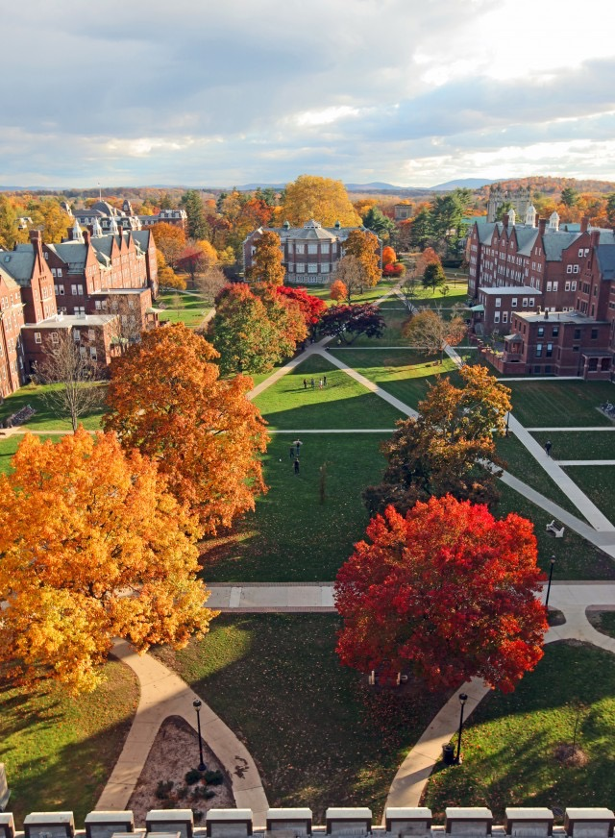



**Dorm room details:** Information about floor plans, window dimensions, furniture and beds, keys, and hall access is available at [residentiallife.vassar.edu/procedures/](http://residentiallife.vassar.edu/procedures/).

**Sending mail/packages:** When incoming packages are received, students will be notified via email to pick up and sign for their packages in Receiving. Students must bring their id when picking up packages.

**Tuned in on campus:** Check out what's happening on campus on Vassar’s social media accounts. Discover, watch, and share original videos. Visit [YouTube.com/vassar](http://www.YouTube.com/vassar), and click on a video to catch a glimpse of student life at, one of the nation’s premier liberal arts colleges. The videos posted on the channel range from students giving “tours” of their dorm rooms, to performances by campus comedy troupes, to a late night session at the Miscellany News student newspaper.

facebook: [facebook.com/vassarcollege](https://www.facebook.com/vassarcollege)

Instagram: [instagram.com/vassar1861/](https://www.instagram.com/vassar1861/)

Twitter: [twitter.com/vassar](https://twitter.com/vassar)

Vassar’s Office of Regional and International Programs organizes events for parents and alumnae/i each year. In past years, these events have taken place in Boston, New York City, London, Los Angeles, San Francisco, Seattle, Shanghai and Washington, D.C.

To view a schedule of events visit [vassar.edu/programs/regional/](http://alums.vassar.edu/programs/regional/).

**Families Weekend**

**September 23 - 24, 2016**

Each September we welcome parents, alumnae/i and friends of Vassar back to campus for Families Weekend. Activities including the walking tours of campus, student performances, forum for discussion with both faculty and administrations, the Arlington Street Fair, and, of course, the Hudson Valley Harvest Reception on the Library lawn. A full schedule will be at [vassar.edu/families/events/weekend/](http://alums.vassar.edu/families/events/weekend/) in early fall.

We suggest planning ahead. Area hotel rooms fill quickly. Families also stay at The Inn at Alumnae/i House, [alumnaehouse.vassar.edu](http://alumnaehouse.vassar.edu), located across the street from campus.

**Local hotel accommodations and restaurants**

Visit [admissions.vassar.edu/visit](http://admissions.vassar.edu/visit/accommodations.html).

families

weekend

regional

and International

Programs

Home away from home

travel

**By plane:** Stewart Airport is located in Newburgh, NY, approximately 40 minutes by car from the Vassar campus. Vassar also provides shuttle transportation to the New York City airports, JFK and LaGuardia, four times during the school year. About a month prior to the October, winter, and spring breaks, the dates and times of the shuttle schedule are sent out in a campus-wide email to all students. Vassar also provides shuttle service at the end of the academic year.

**By train:** The Poughkeepsie Train Station is serviced by Amtrak and

MetroNorth. MetroNorth goes south to Grand Central Station in

New York City (leaving hourly at 33 minutes past the hour on weekdays, more frequently during rush hours, and at regular intervals on weekends). Amtrak goes both north to Albany and south to Pennsylvania Station in New York City. Call for schedule information.

**By car:** You’ll find directions for driving to campus at [info.vassar.edu/visit](http://info.vassar.edu/visit/).

**Without a car?** Zipcar has also become a practical alternative to bringing a car to campus. Students can sign up to use two available cars on campus that are provided by the nationwide Zipcar rental system. Go online to [zipcar.com/vassar](http://www.apple.com) to register for special rates.

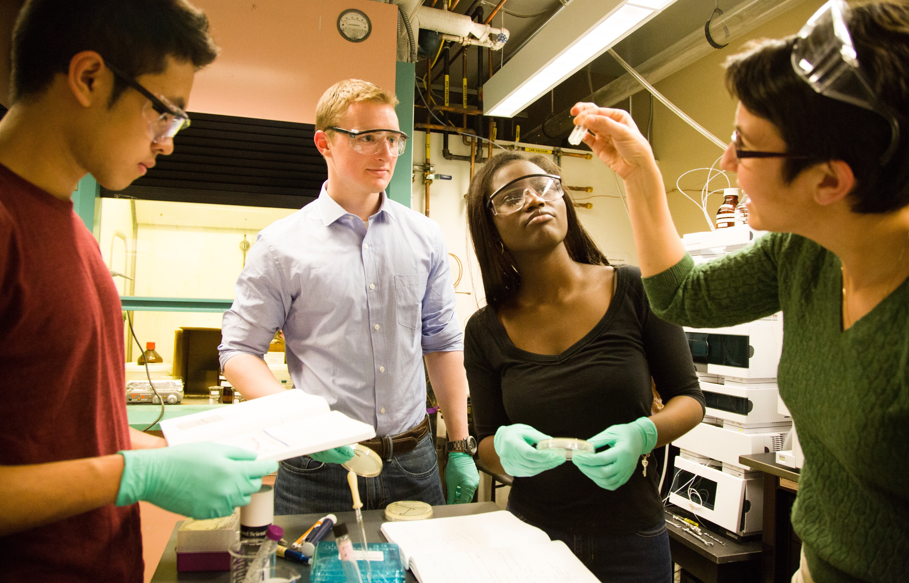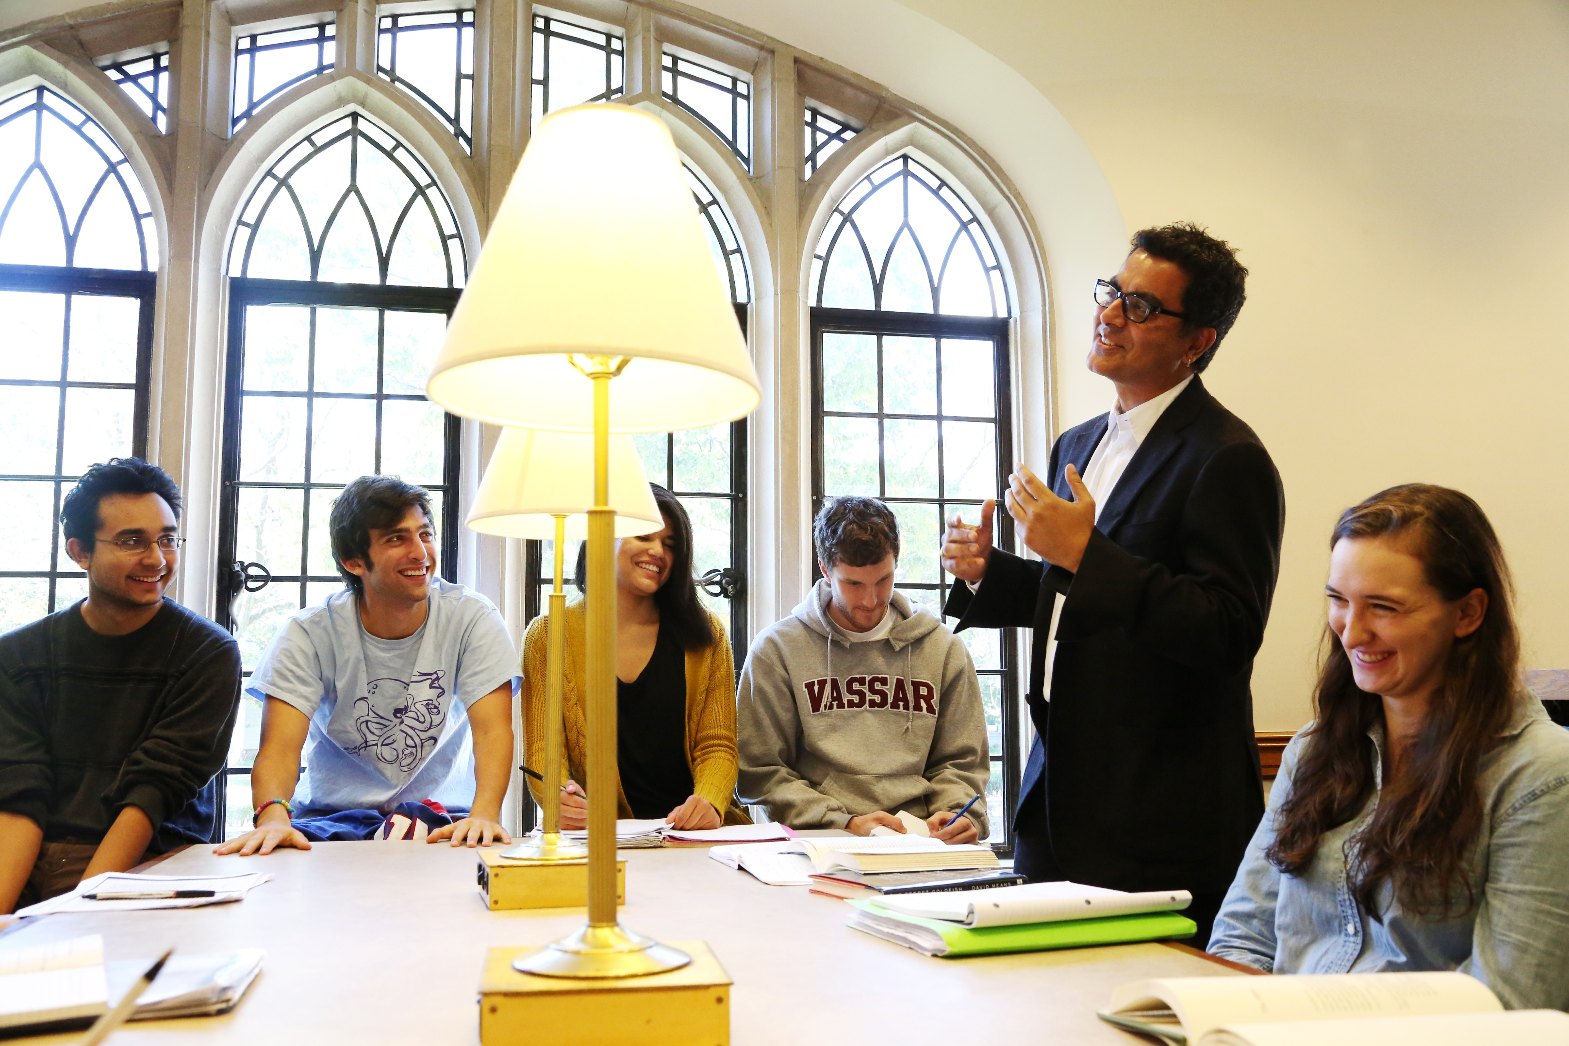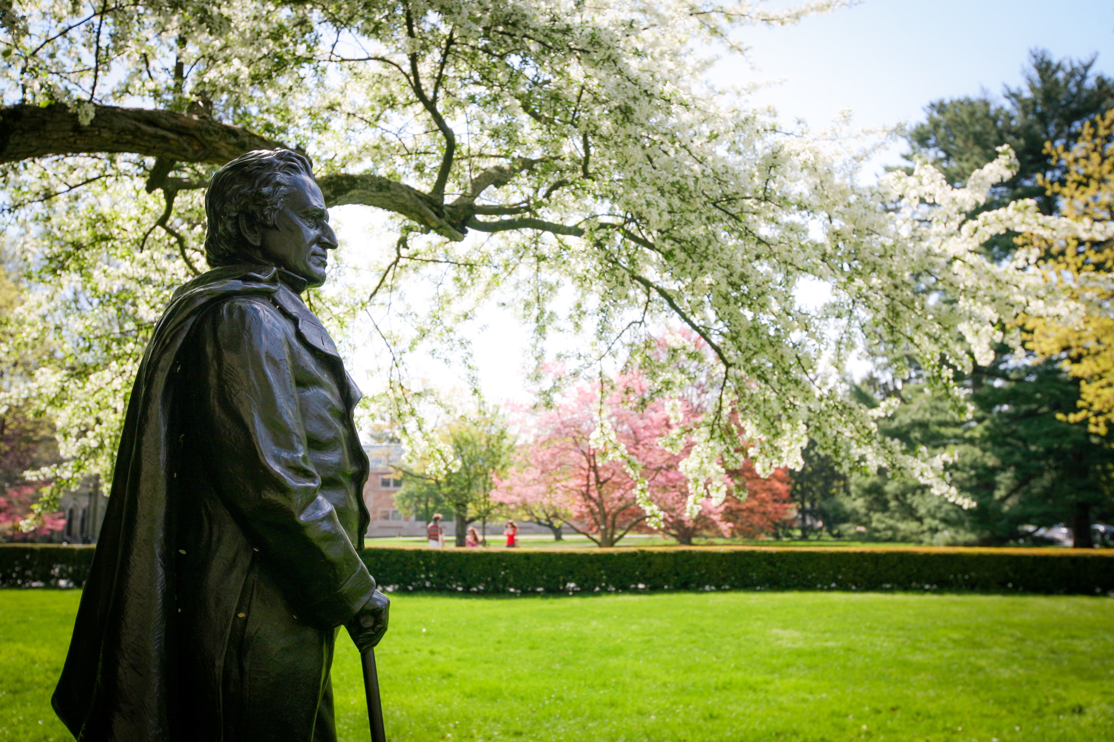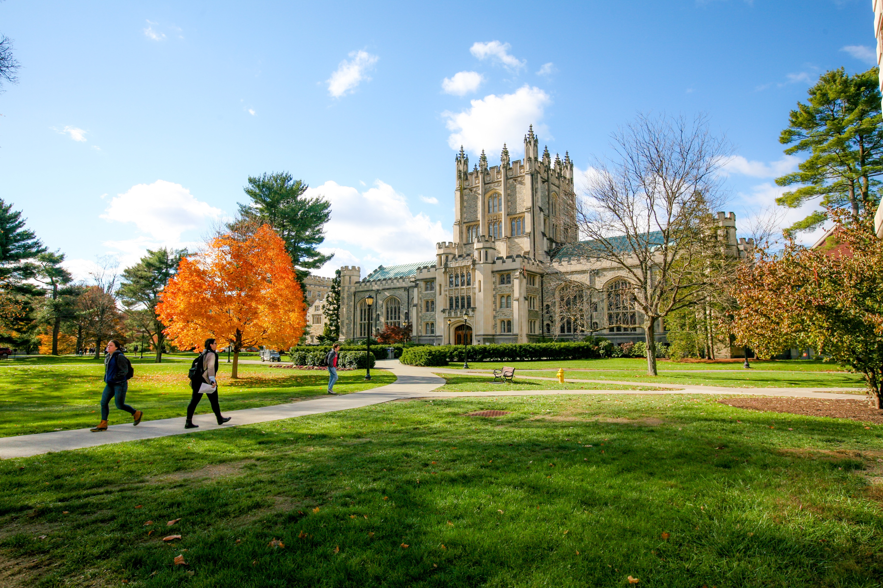

The Vassar website offers many resources to better acquaint parents with how students seek and receive support in all aspects of their experience while on campus. Below is a list of people and offices parents can suggest students contact with questions or concerns.

2016-2017 Academic Calendar

**First Semester**

Aug. 22 Class of 2020 arrival day

Aug. 22-27 First-year orientation

Aug. 27 Residence halls open; upper classes return

Aug. 29 First semester classes begin

Sept. 7 Fall Convocation

Sept. 24-25 All Families Weekend

Oct. 14-23 October Break (no classes)

Nov. 23-27 Thanksgiving recess

Dec. 7 Last classes of first semester

Dec. 8-11 Study Period

Dec. 12-16 First Semester examinations

Dec. 17 Residence halls close for winter recess

**Second Semester**

Jan. 20-22 Sophomore Career Connections

Jan. 25 Second semester classes begin

March 10-26 Spring recess (residence halls closed)

May 6 Founder’s Day

May 9 Last classes of second semester

May 10-16 Study Period

May 17-23 Second Semester examinations

May 28 Commencement

**Summer 2017**

June 9-11 Reunion Weekend

*Schedule subject to change

Planning ahead? Visit [info.vassar.edu/resources/academic/calendar](http://info.vassar.edu/resources/academic/calendar.html)for calendars through the summer of 2019.

Key Contacts

[aeo@vassar.edu](mailto:aeo@vassar.edu)

[admissions@vassar.edu](mailto:admissions@vassar.edu)

[benathan@vassar.edu](mailto:benathan@vassar.edu)

[campusactivities@vassar.edu](mailto:campusactivities@vassar.edu)

[cdo@vassar.edu](mailto:cdo@vassar.edu)

[servicedesk@vassar.edu](mailto:servicedesk@vassar.edu)

[counseling@vassar.edu](mailto:counseling@vassar.edu)

[deanstudents@vassar.edu](mailto:deanstudents@vassar.edu)

845-437-7333

[health@vassar.edu](mailto:health@vassar.edu)

[jya@vassar.edu](mailto:jya@vassar.edu)

[presidentsoffice@vassar.edu](mailto:presidentsoffice@vassar.edu)

[registrar@vassar.edu](mailto:registrar@vassar.edu)

[reslife@vassar.edu](mailto:reslife@vassar.edu)

[arsabo@vassar.edu](mailto:arsabo@vassar.edu) (845-437-5200)

[stuaccounts@vassar.edu](mailto:stuaccounts@vassar.edu)

[stuemp@vassar.edu](mailto:stuemp@vassar.edu)

Accessibility and Educational Opportunity

Admissions

ALANA Center

Campus Activities

Career Center

Computing and Information Services

Counseling Services

Dean of Students

Emergency

Health Services

International Programs

Office of the President

Registrar

Residential Life

Security

Student Accounts

Student Employment

For a complete directory, visit [vassar.edu/directory](https://aisapps.vassar.edu/directory/index.php)